Producer Report 2 for B-tree Visualization Project

Director: Samuel Morrison

Producer: Brayden Peck

Other team members: Conley O'Neill, Thomas Wood

# Section 1 Current Tasks

Tasks for this period.

|  |  |  |  |  |  |
| --- | --- | --- | --- | --- | --- |
| Task | Complete/Incomplete | Assigned to | Start Date | Time spent (total) | Comments |
| Recode existing code in C++ | Incomplete | All | 9/2 | ~40 | This part took much longer than expected to get the b tree classes working in C++ |
| Finalize B tree node | Complete | Brayden | 9/2 | 6 | This class should be finalized but adjustments may need to be made as new features get added to the B Tree |
| Search method B tree | Incomplete | Brayden | 9/2 | ~ | This is blocked until the insert method is working properly |
| Insert method B tree | Incomplete | Brayden | 9/2 | 5 | This method is mostly working but there is still some bugs that need to be sorted out |
| Delete method B tree | Incomplete | Brayden | 9/2 | ~ | This is blocked until the insert method is working properly |
| Finialize B+ tree node | Complete | Samuel | 9/2 | 4 | This class should be finalized but adjustments may need to be made as new features get added to the B+ Tree |
| Search method B+ tree | Incomplete | Samuel | 9/2 | ~ | This is blocked until the insert method is working properly |
| Insert method B+ tree | Complete | Samuel | 9/2 | 7 | Insert is working properly and has been tested |
| Delete method B+ tree | Incomplete | Samuel | 9/2 | 3 | This method is able to pull from the left and right children but the nodes still need to be merged. |

# Section 2 Completed Tasks

Completed tasks:

|  |  |  |  |  |
| --- | --- | --- | --- | --- |
| Task | Assigned to | Estimated completion time | Actual completion time | Start Date |
| B Tree Node | Brayden | 5 | 6 | 9/2 |
| B+ Tree Node | Samuel | 5 | 4 | 9/2 |
| B+ Tree Insert | Samuel | 5 | 7 | 9/2 |
| GUI Resizing | Conley, Thomas | 4 | 5 | 9/12 |

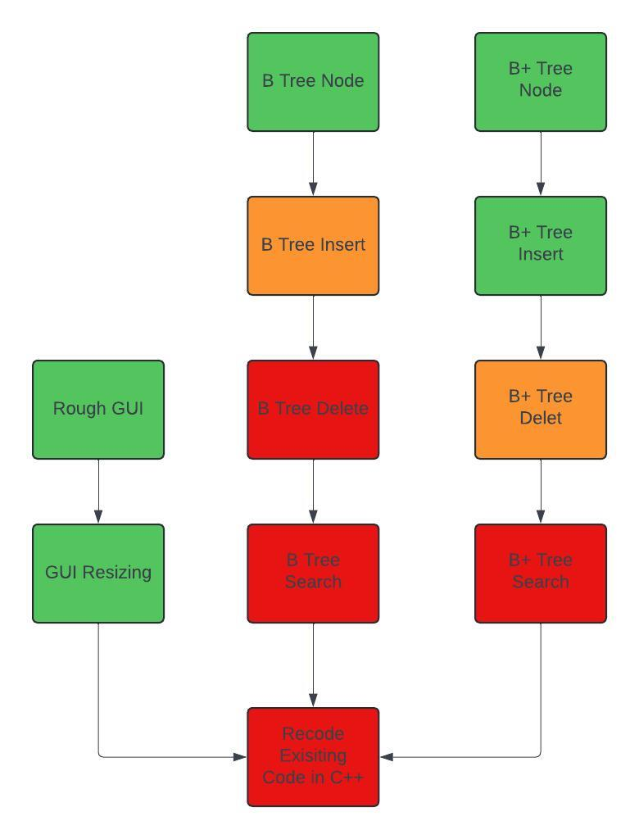

Meeting schedule

|  |  |  |
| --- | --- | --- |
| Date | Time | Attendance |
| 9/20 | 8:00am – 8:50am | All |
| 9/23 | 8:00am – 8:50am | All |
| 9/25 | 8:00am – 8:50am | All |
| 9/27 | 8:00am – 8:50am | All |
| 9/30 | 8:00am – 8:50am | All |
| 10/2 | 8:00am – 8:50am | All |
| 10/4 | 8:00am – 8:50am | Brayden Samuel Conley |
| 10/7 | 8:00am – 8:50am | Brayden Samuel Conley |
| 10/9 | 8:00am – 8:50am | All |

# Section 3 Incomplete Tasks

1) recode existing codebase

1.1) B Tree insert

1.1.1 ) insert into nodes (complete)

1.1.2 ) split root node (complete)

1.1.3) split node (incomplete) some bugs to fix here

1.2) B Tree search (search waiting on insert)

1.3) B Tree delete (delete waiting on insert)

1.4) B+ tree delete

1.4.1) remove key (complete)

1.4.2) take number from left (complete)

1.4.3) take number from right (complete)

1.4.4) merge left (incomplete)

1.4.5) merge right (incomplete)

1.5) B+ tree search (waiting on delete)

# Section 4 Upcoming Tasks

Upcoming / Incomplete tasks

|  |  |  |  |
| --- | --- | --- | --- |
| Task | Assigned to | Estimated Time Spent | Estimated Start Date |
| Finalize B tree node | Brayden | 5 | 9/2 |
| Search method B tree | Brayden | 5 | 9/2 |
| Insert method B tree | Brayden | 5 | 9/2 |
| Delete method B tree | Brayden | 5 | 9/2 |
| Finalize B+ tree node | Samuel | 5 | 9/2 |
| Search method B+ tree | Samuel | 5 | 9/2 |
| Insert method B+ tree | Samuel | 5 | 9/2 |
| Delete method B+ tree | Samuel | 5 | 9/2 |
| Linking GUI to Code backend (no display) | Conley, Thomas | 2 | 10/11 |
| Display Data Structures in GUI | Conley, Thomas | 10 | 10/11 |